**Architecture Diagram**

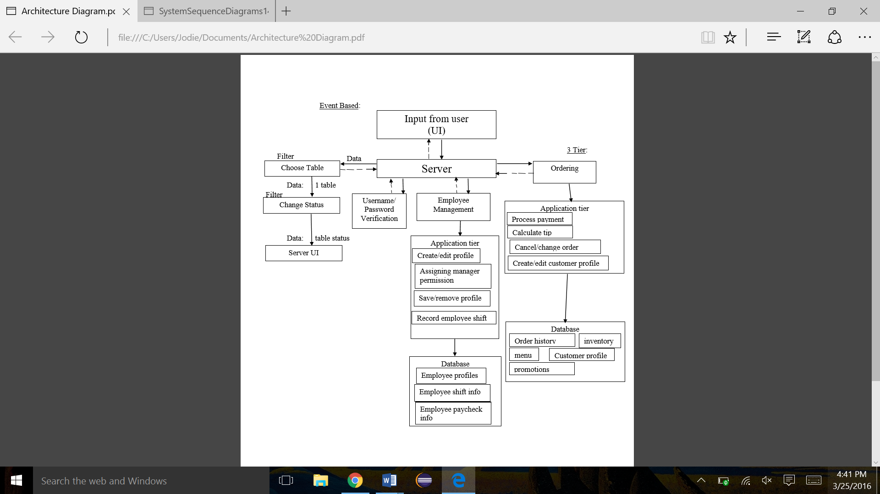

For our architecture diagram, we chose three different kinds of diagrams to represent our system. The first was event-based, which made sense to us as most of the actions in the restaurant system would be based on events of users choosing one of the options (open menu, login, and etcetera). The second type of architecture we chose was the pipe and filter architecture. We chose this for the ‘Choose table’ part of our system because one of the pros of this type is that the filter pipelines perform multiple operations concurrently. This would be useful to a restaurant system, especially with seating, as you will often be changing the status of multiple tables at a time. The 3 Tier architecture was chosen to manage the tasks associated with employee and customer management. It was essential to have a database for the employees and the customers, and we thought it would be best if the database was kept separate from the logic/applications, such as calculating the tip, recording employee shift, and so on. This architecture helps us to incorporate increasing levels of abstraction, reusability, and enhancement.